МІНІСТЕРСТВО ОСВІТИ І НАУКИ УКРАЇНИ

ЧЕРНІГІВСЬКИЙ НАЦІОНАЛЬНИЙ ТЕХНОЛОГІЧНИЙ УНІВЕРСИТЕТ

КАФЕДРА ІНФОРМАЦІЙНИХ ТА КОМП'ЮТЕРНИХ СИСТЕМ

**Розрахунково-графічна робота**

**З дисципліни "Проектування web-інтерфейсів"**

|  |  |  |
| --- | --- | --- |
| Виконав:  студент групи КІт-191 |  | Кривопуск О.В. |
| Перевірив:  старший викладач |  | Бивойно Т.П. |

Чернігів 2020

**Расчетно-графическая работа**

**СОЗДАНИЕ СОБСТВЕННОГО ВЕБ-САЙТА**

**Цель работы:**

Закрепить знания и умения, полученные при выполнении лабораторных работ 1,2 и 3. Продемонстрировать социальные и творческие способности, желание и умение создавать красивый несложный веб -сайт. Принести автору дополнительные рейтинговые баллы и вывести его на более

высокий уровень успеваемости по дисциплине.

**1) Задание на расчетно-графическую работу**

Создать статический сайт соответствующий следующим требованиям:

– Сайт должен быть посвящен личности автора РГР.

– Структура всех страниц сайта типичная (1-3-1).

– Сайт должен иметь 4 станицы (Главная страница, Мои увлечения, За что я люблю свои девайсы , Любимое живое существо)

– Площадь страницы делить с помощью тега div. Таблицы и фреймы не применять.

– Максимально использовать CSS. Стили выносить во внешние файлы.

– Разместить сайт на локальном сервере в специально созданном для РГР

виртуальном хосте.

– Организовать программную генерацию на своем персональном сайте дополнительной страницы «Работа с Javascript» и организовать парольный

переход на нее с главной страницы. Базу логинов-паролей организовать в

виде локального текстового файла D:\secrets.txt. Предусмотреть возможность регистрации новых посетителей этой «секретной» страницы.

– На этой странице реализовать дополнительные функциональные возможности.

|  |  |
| --- | --- |
| Вариант | Задание на РГР |
| 0 | Реализовать графический компонент DATA TABLE (таблица с переключениями между страницами). Суть его работы заключается в: получении большого списка записей, например из таблицы базы данных или создаваемый из JavaScript на странице (список уже из 100 элементов не помещается полностью на одной странице и создает пользователю неудобства при работе. В компоненте отображается только часть списка, например, с 0 до 30, с 30 до 60, с 60 до 90 и с 90 до 100. Для того, чтобы отобразить элементы списка записей с 0 до 30 необходимо нажать на кнопку “1 страница” создаваемого компонента. Для вывода с 30 по 60 записи -“2 страница” и т.д Подсказка: элементы таблицы хранить в формате JSON. |

**2) Выполнение работы**

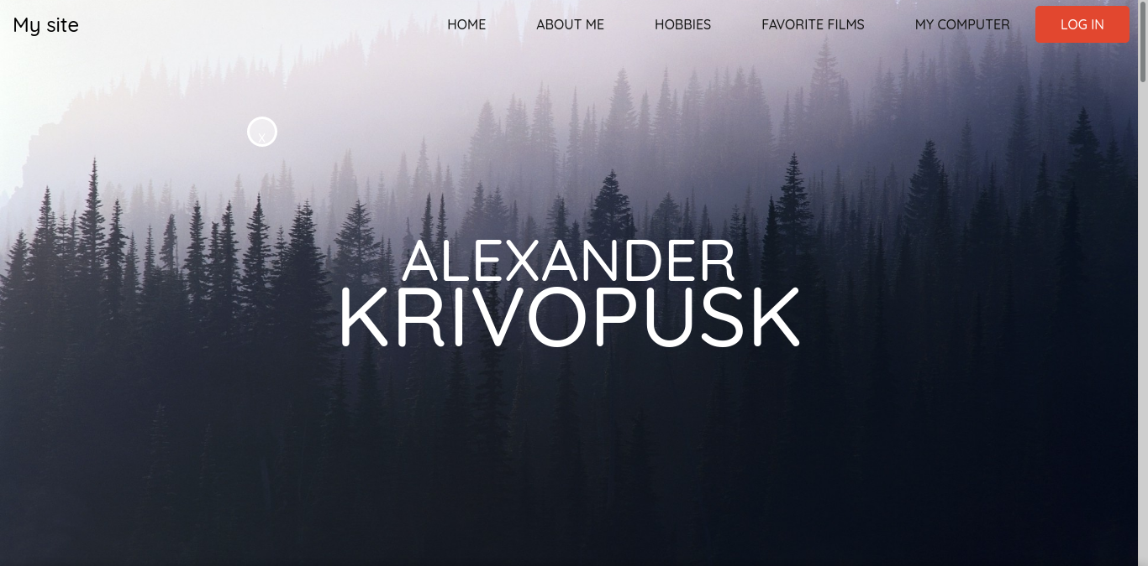

Рисунок 1 – страница «HOME»

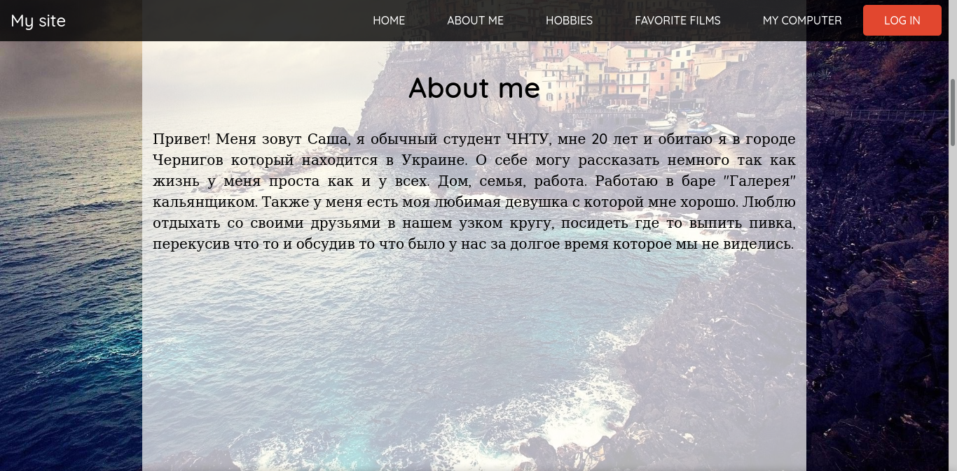

Рисунок 2 –страница «ABOUT ME »

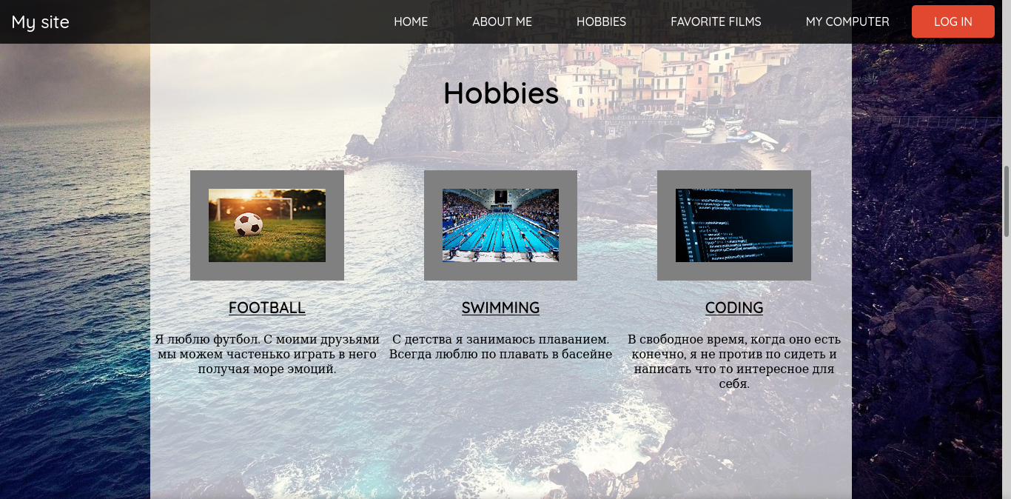

Рисунок 3 – страница «HOBBIES»

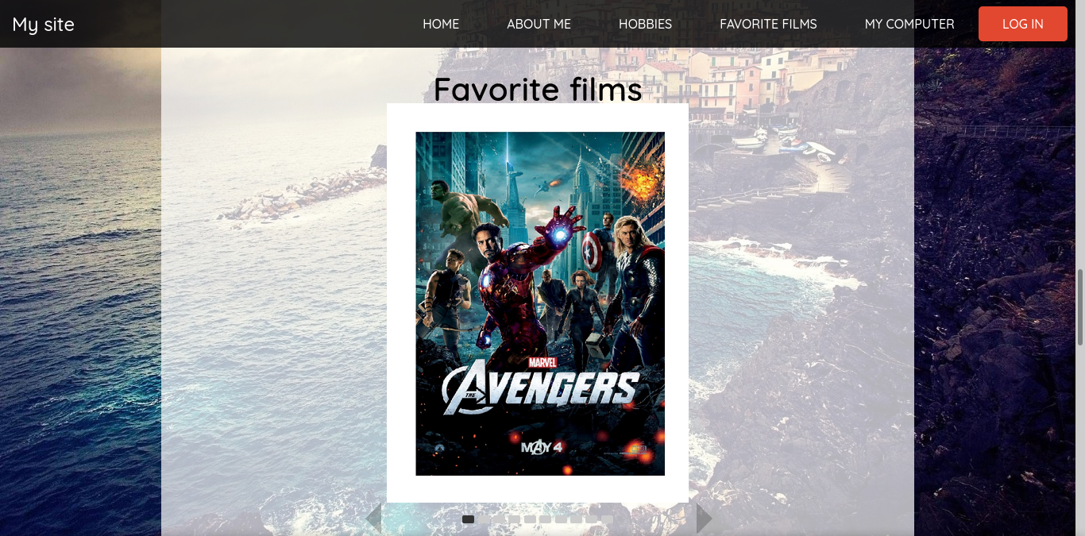

Рисунок 4 –страница «FAVORUTE FILMS»

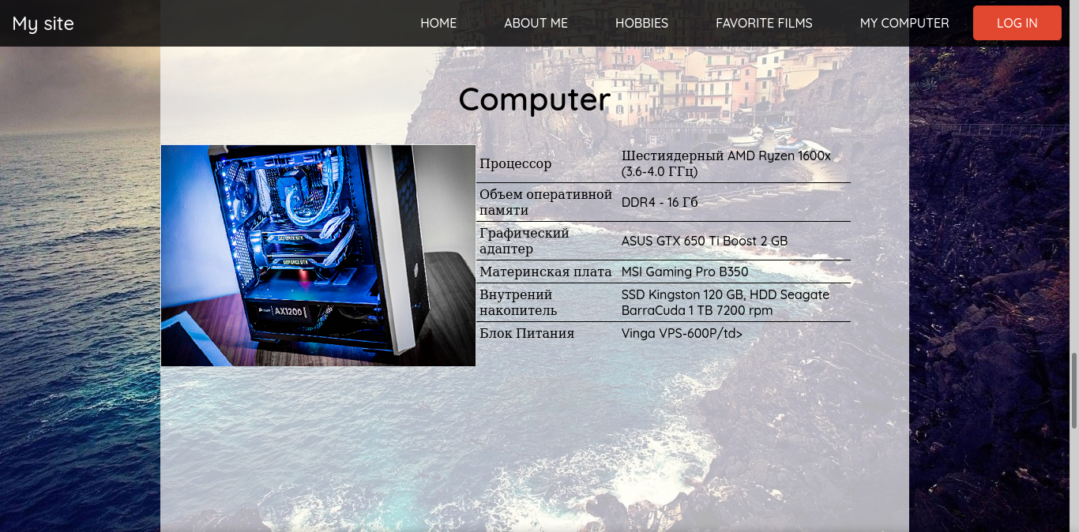

Рисунок 5 –страница «MY COMPUTER»

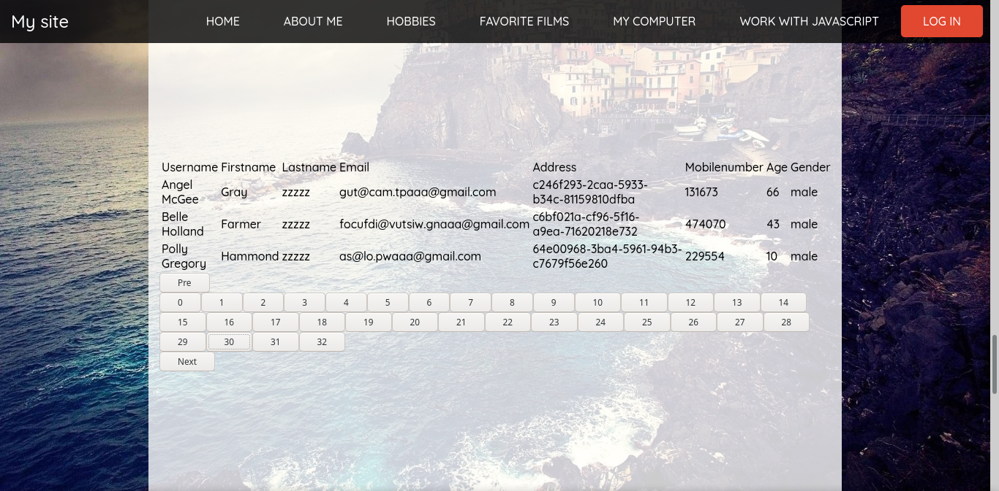

Рисунок 6 –страница «Работа с JavaScript» (вторая часть ргр)

**Код сайта:**

<!DOCTYPE html>

<html>

<head>

<meta charset="utf-8">

<title>My site</title>

<link rel="stylesheet" href="css/style.css">

<link rel="stylesheet" href="css/slider.css">

<link href="https://fonts.googleapis.com/css?family=Quicksand:500" rel="stylesheet">

<script src="https://code.jquery.com/jquery-3.2.1.js"></script>

<script src="http://ajax.googleapis.com/ajax/libs/jquery/1.12.4/jquery.min.js"></script>

<script src="log.php"></script>

</head>

<body>

<div class="wrapper">

<nav>

<div class="logo"><a href="/index.html">My site</a></div>

<ul>

<li><a href="#home" data-target="anchor">Home</a></li>

<li><a href="#about_me" data-target="anchor">About me</a></li>

<li><a href="#hobbies" data-target="anchor">Hobbies</a></li>

<li><a href="#favorite_films" data-target="anchor">Favorite films</a></li>

<li><a href="#Computer" data-target="anchor">My Computer</a></li>

<li><a href="#pag-container" data-target="anchor">Work with JavaScript</a></li>

<li><a class="active" href="#login" data-target="anchor">Log In</a></li>

</ul>

</nav>

</div>

<header id="home">

<div id="banner">

</div>

<div class="first_name">ALEXANDER</div>

<div class="second_name">Krivopusk</div>

</header>

<section>

<div class="container">

<div id="about_me">

<h1>About me</h1>

<p>Привет! Меня зовут Саша, я обычный студент ЧНТУ, мне 20 лет и обитаю я в городе Чернигов который находится в Украине. О себе могу рассказать немного так как жизнь у меня проста как и у всех. Дом, семья, работа. Работаю в баре "Галерея" кальянщиком. Также у меня есть моя любимая девушка с которой мне хорошо.

Люблю отдыхать со своими друзьями в нашем узком кругу, посидеть где то выпить пивка, перекусив что то и обсудив то что было у нас за долгое время которое мы не виделись.

</p>

</div>

</div>

</section>

<section>

<div class="container">

<div id="hobbies">

<h1>Hobbies</h1>

<div class="hobbies_item">

<img src="img/hobbies/football.png" alt="">

<h3>Football</h3>

<p>Я люблю футбол.

С моими друзьями мы можем частенько играть в него получая море эмоций.</p>

</div>

<div class="hobbies_item">

<img src="img/hobbies/swimming.png" alt="">

<h3>Swimming</h3>

<p>С детства я занимаюсь плаванием. Всегда люблю по плавать в басейне</p>

</div>

<div class="hobbies_item">

<img src="img/hobbies/coding.png" alt="">

<h3>Coding</h3>

<p>В свободное время, когда оно есть конечно, я не против по сидеть и написать

что то интересное для себя.</p>

</div>

</div>

</div>

</section>

<section>

<div class="container">

<div id="favorite_films">

<h1>Favorite films</h1>

<div id="slider">

<input type="radio" name="slider" id="slide1" checked="">

<input type="radio" name="slider" id="slide2">

<input type="radio" name="slider" id="slide3">

<input type="radio" name="slider" id="slide4">

<input type="radio" name="slider" id="slide5">

<input type="radio" name="slider" id="slide6">

<input type="radio" name="slider" id="slide7">

<input type="radio" name="slider" id="slide8">

<input type="radio" name="slider" id="slide9">

<input type="radio" name="slider" id="slide10">

<div id="slides">

<div id="overflow">

<div class="inner">

<div class="page">

<img src="img/films/avengers.png" />

</div>

<div class="page">

<img src="img/films/avengers2.png" />

</div>

<div class="page">

<img src="img/films/avengers3.png" />

</div>

<div class="page">

<img src="img/films/ironman1.png" />

</div>

<div class="page">

<img src="img/films/ironman2.png" />

</div>

<div class="page">

<img src="img/films/ironman3.png" />

</div>

<div class="page">

<img src="img/films/tor3.png" />

</div>

<div class="page">

<img src="img/films/it.jpg" />

</div>

<div class="page">

<img src="img/films/pirates.jpg" />

</div>

<div class="page">

<img src="img/films/rpo.jpg" />

</div>

</div> <!--inner-->

</div> <!--overflow-->

</div> <!--slides-->

<div id="controls">

<label for="slide1"></label>

<label for="slide2"></label>

<label for="slide3"></label>

<label for="slide4"></label>

<label for="slide5"></label>

<label for="slide6"></label>

<label for="slide7"></label>

<label for="slide8"></label>

<label for="slide9"></label>

<label for="slide10"></label>

</div>

<div id="active">

<label for="slide1"></label>

<label for="slide2"></label>

<label for="slide3"></label>

<label for="slide4"></label>

<label for="slide5"></label>

<label for="slide6"></label>

<label for="slide7"></label>

<label for="slide8"></label>

<label for="slide9"></label>

<label for="slide10"></label>

</div>

</div>

</div>

</div>

</section>

<section>

<div class="container">

<div id="Computer">

<h1>Computer</h1>

<div>

<img src="img/Computer.png">

</div>

<div>

<table class="Computer" cellspacing="10" cellpadding="4" rules="rows">

<tr>

<td>Процессор</td>

<td>Шестиядерный AMD Ryzen 1600x (3.6-4.0 ГГц)</td>

</tr>

<tr>

<td>Объем оперативной памяти</td>

<td>DDR4 - 16 Гб</td>

</tr>

<tr>

<td>Графический адаптер</td>

<td>ASUS GTX 650 Ti Boost 2 GB</td>

</tr>

<tr>

<td>Материнская плата</td>

<td>MSI Gaming Pro B350</td>

</tr>

<tr>

<td>Внутрений накопитель</td>

<td>SSD Kingston 120 GB, HDD Seagate BarraCuda 1 TB 7200 rpm</td>

</tr>

<tr>

<td>Блок Питания</td>

<td>Vinga VPS-600P/td>

</tr>

</table>

</div>

</div>

</div>

</section>

<section>

<div class="container">

<div id="pag-container">

<div>

<table>

<thead>

<tr class="bgColor">

<td>Username</td>

<td>Firstname</td>

<td>Lastname</td>

<td>Email</td>

<td>Address</td>

<td>Mobilenumber</td>

<td>Age</td>

<td>Gender</td>

</tr>

</thead>

<tbody id="myTable">

</tbody>

</table>

</div>

<div>

<div>

<button id="PreValue">Pre</button>

</div>

<div class="nav"></div>

<div>

<button id="nextValue">Next</button>

</div>

</div>

</div>

</main>

<script src="https://cdnjs.cloudflare.com/ajax/libs/jquery/3.5.1/jquery.min.js" integrity="sha256-9/aliU8dGd2tb6OSsuzixeV4y/faTqgFtohetphbbj0=" crossorigin="anonymous"></script>

<script src="/scripts/main.js"></script>

</div>

</section>

<section>

<div id="login">

<div class="signin">

<form method="POST" action="log.php">

<h2>Log In</h2>

<input type="text" placeholder="Enter Username" name="login">

<input type="password" placeholder="Enter Password" name="pass">

<button type="submit" class="btnsub">Log in</button>

</form>

</div>

</div>

</section>

<script type="text/javascript" src="/scripts/script.js"></script>

</body>

</html>

**Код скриптов:**

var userDetails=[

{

"Username":"Annie Norman",

"Firstname":"Huff",

"Lastname":"zzzzz",

"Email": "rizdamez@lebopo.myaaa@gmail.com",

"Address":"af258c87-7d8e-5188-9b28-86c4bcb97cb5",

"Mobilenumber":"658363",

"Age":"59",

"Gender":"male"

},

{

"Username":"Randall Rodriguez",

"Firstname":"Lloyd",

"Lastname":"zzzzz",

"Email": "kin@jepdu.soaaa@gmail.com",

"Address":"bd4ae982-202b-51f3-ac3a-ec7ab25b7014",

"Mobilenumber":"959386",

"Age":"89",

"Gender":"male"

},

{

"Username":"Glenn Mills",

"Firstname":"Barber",

"Lastname":"zzzzz",

"Email": "tipuhpi@kolziroc.bvaaa@gmail.com",

"Address":"b59f3477-2a7b-593f-bf14-f5a745131b77",

"Mobilenumber":"923647",

"Age":"64",

"Gender":"male"

},

{

"Username":"Leroy May",

"Firstname":"Soto",

"Lastname":"zzzzz",

"Email": "notke@fois.mhaaa@gmail.com",

"Address":"3cf0c28c-d9e9-53da-9426-0b8324296a8d",

"Mobilenumber":"907238",

"Age":"8",

"Gender":"male"

},

{

"Username":"Trevor Murphy",

"Firstname":"Silva",

"Lastname":"zzzzz",

"Email": "he@dolfu.gmaaa@gmail.com",

"Address":"daf4c018-df4a-53c7-9ee6-416724a5cf5f",

"Mobilenumber":"306887",

"Age":"24",

"Gender":"male"

},

{

"Username":"Carl Vega",

"Firstname":"Carpenter",

"Lastname":"zzzzz",

"Email": "eka@uc.cfaaa@gmail.com",

"Address":"01ac7b87-526c-555b-9f4e-d064d781d481",

"Mobilenumber":"593783",

"Age":"82",

"Gender":"male"

},

{

"Username":"Todd Haynes",

"Firstname":"Paul",

"Lastname":"zzzzz",

"Email": "pavadhag@hutufma.pwaaa@gmail.com",

"Address":"7fc98393-8ab3-5925-890a-ca43b9719c35",

"Mobilenumber":"324285",

"Age":"24",

"Gender":"male"

},

{

"Username":"Bess Schwartz",

"Firstname":"Gardner",

"Lastname":"zzzzz",

"Email": "cisjirbe@iroecida.cgaaa@gmail.com",

"Address":"fef5dcbf-0bc4-5916-9861-52aa84baae64",

"Mobilenumber":"819299",

"Age":"51",

"Gender":"male"

},

{

"Username":"Catherine Black",

"Firstname":"Washington",

"Lastname":"zzzzz",

"Email": "ulocafa@nuhnifkig.beaaa@gmail.com",

"Address":"033f6fdc-bcd6-5e73-ba70-c219d2a3bdfd",

"Mobilenumber":"661155",

"Age":"100",

"Gender":"male"

},

{

"Username":"Maria Long",

"Firstname":"Curtis",

"Lastname":"zzzzz",

"Email": "besufasu@si.bdaaa@gmail.com",

"Address":"3e2e76f9-0fb1-52bc-b8a2-784960929684",

"Mobilenumber":"629286",

"Age":"4",

"Gender":"male"

},

{

"Username":"Evan Morales",

"Firstname":"Bishop",

"Lastname":"zzzzz",

"Email": "itsana@jazpurod.gaaaa@gmail.com",

"Address":"4a82e925-bf1e-56cc-b35e-5ce9d071b924",

"Mobilenumber":"168926",

"Age":"55",

"Gender":"male"

},

{

"Username":"Myrtle Clarke",

"Firstname":"Blair",

"Lastname":"zzzzz",

"Email": "turka@fug.peaaa@gmail.com",

"Address":"0552d145-5cf1-58d9-a8fc-18ebb0f648bd",

"Mobilenumber":"264054",

"Age":"50",

"Gender":"male"

},

{

"Username":"Julian Rodgers",

"Firstname":"Lawrence",

"Lastname":"zzzzz",

"Email": "mij@wahajvah.tzaaa@gmail.com",

"Address":"c1db0356-57c7-5f0d-acb3-f79db39fa5de",

"Mobilenumber":"310279",

"Age":"96",

"Gender":"male"

},

{

"Username":"Polly Maxwell",

"Firstname":"Silva",

"Lastname":"zzzzz",

"Email": "jum@luh.ghaaa@gmail.com",

"Address":"951e771e-2ca8-5809-8c4a-40d71a363d13",

"Mobilenumber":"372174",

"Age":"26",

"Gender":"male"

},

{

"Username":"Joseph Love",

"Firstname":"Torres",

"Lastname":"zzzzz",

"Email": "cas@sipefe.lraaa@gmail.com",

"Address":"72637e1a-2584-5b57-947f-d4b87ebc58fc",

"Mobilenumber":"117279",

"Age":"82",

"Gender":"male"

},

{

"Username":"Andrew Mathis",

"Firstname":"Cole",

"Lastname":"zzzzz",

"Email": "zohlihkom@bilivmu.gbaaa@gmail.com",

"Address":"372b1480-6d2c-5dc6-ba77-c03b179d7051",

"Mobilenumber":"909567",

"Age":"99",

"Gender":"male"

},

{

"Username":"Stella Maldonado",

"Firstname":"Gibbs",

"Lastname":"zzzzz",

"Email": "jadowmi@ed.claaa@gmail.com",

"Address":"38aa4d90-75a1-51d5-b745-2bb12fc6a572",

"Mobilenumber":"553415",

"Age":"56",

"Gender":"male"

},

{

"Username":"Blake Page",

"Firstname":"Rogers",

"Lastname":"zzzzz",

"Email": "wipma@zevogdah.isaaa@gmail.com",

"Address":"89c03f96-0b00-5b54-938a-79f2951fc577",

"Mobilenumber":"446831",

"Age":"18",

"Gender":"male"

},

{

"Username":"Georgia Atkins",

"Firstname":"Payne",

"Lastname":"zzzzz",

"Email": "cigmatja@ohenu.hmaaa@gmail.com",

"Address":"ee987364-16ee-5a67-a286-a82765a7c5e1",

"Mobilenumber":"476719",

"Age":"20",

"Gender":"male"

},

{

"Username":"Willie Herrera",

"Firstname":"Rodriquez",

"Lastname":"zzzzz",

"Email": "mekwa@kocuz.ukaaa@gmail.com",

"Address":"08a9cf5d-1639-5b64-939b-dbcc1179ecd1",

"Mobilenumber":"543425",

"Age":"67",

"Gender":"male"

},

{

"Username":"Mamie Hudson",

"Firstname":"Pope",

"Lastname":"zzzzz",

"Email": "zudla@fahejpap.biaaa@gmail.com",

"Address":"1ec9cfc6-c36f-5b12-8092-dd9a1eb3738e",

"Mobilenumber":"355750",

"Age":"23",

"Gender":"male"

},

{

"Username":"Charlotte Oliver",

"Firstname":"Dennis",

"Lastname":"zzzzz",

"Email": "wutud@fe.lcaaa@gmail.com",

"Address":"aeb1e615-1797-52b4-a3b6-ebdae4e5d4ce",

"Mobilenumber":"533592",

"Age":"83",

"Gender":"male"

},

{

"Username":"Donald Roberson",

"Firstname":"Morgan",

"Lastname":"zzzzz",

"Email": "zagnaic@hob.tmaaa@gmail.com",

"Address":"08853a78-ce14-5a0e-bfa8-71e68ad5faf8",

"Mobilenumber":"484104",

"Age":"76",

"Gender":"male"

},

{

"Username":"Raymond Simpson",

"Firstname":"Stevenson",

"Lastname":"zzzzz",

"Email": "savho@cenhuzig.sbaaa@gmail.com",

"Address":"2be95a7a-de93-5a4a-ae79-2e404fe1882f",

"Mobilenumber":"164631",

"Age":"72",

"Gender":"male"

},

{

"Username":"Floyd Larson",

"Firstname":"Taylor",

"Lastname":"zzzzz",

"Email": "ebte@liwja.zaaaa@gmail.com",

"Address":"9199bdf6-0c26-5e4e-87fc-6000f308a26f",

"Mobilenumber":"829009",

"Age":"51",

"Gender":"male"

},

{

"Username":"Alice Stokes",

"Firstname":"Park",

"Lastname":"zzzzz",

"Email": "rejispi@giriblat.gfaaa@gmail.com",

"Address":"27946e72-dab9-581e-a985-22fbbb0e1913",

"Mobilenumber":"407668",

"Age":"79",

"Gender":"male"

},

{

"Username":"Marc Tyler",

"Firstname":"Jimenez",

"Lastname":"zzzzz",

"Email": "ca@pippil.joaaa@gmail.com",

"Address":"18668b12-4228-59f4-89ce-50cdeaaba52e",

"Mobilenumber":"358150",

"Age":"31",

"Gender":"male"

},

{

"Username":"Irene Bush",

"Firstname":"Christensen",

"Lastname":"zzzzz",

"Email": "ubbibuk@zovmigare.ioaaa@gmail.com",

"Address":"c1972b40-4a02-59a1-b1e8-d2550e5d1389",

"Mobilenumber":"441975",

"Age":"25",

"Gender":"male"

},

{

"Username":"Mike Medina",

"Firstname":"Alvarado",

"Lastname":"zzzzz",

"Email": "tofob@lisnuvu.fkaaa@gmail.com",

"Address":"78c60b57-c190-597e-afbf-075fd8164519",

"Mobilenumber":"921399",

"Age":"99",

"Gender":"male"

},

{

"Username":"Jimmy Kennedy",

"Firstname":"Sharp",

"Lastname":"zzzzz",

"Email": "ad@revafhuw.keaaa@gmail.com",

"Address":"a6af99bf-2ee1-5e95-9d01-5fb415b0e622",

"Mobilenumber":"706109",

"Age":"92",

"Gender":"male"

},

{

"Username":"Timothy Adkins",

"Firstname":"Poole",

"Lastname":"zzzzz",

"Email": "ur@sivvedu.co.ukaaa@gmail.com",

"Address":"dc42e9e3-3c53-558d-87b9-b12dc07eaa67",

"Mobilenumber":"596314",

"Age":"37",

"Gender":"male"

},

{

"Username":"Steve Lynch",

"Firstname":"Sparks",

"Lastname":"zzzzz",

"Email": "rommuzu@vojfe.coaaa@gmail.com",

"Address":"9d8aac00-fb0a-5ab8-a702-31cb3ef394e5",

"Mobilenumber":"458339",

"Age":"67",

"Gender":"male"

},

{

"Username":"Ethel Barnes",

"Firstname":"Cunningham",

"Lastname":"zzzzz",

"Email": "utimakaj@mujiz.esaaa@gmail.com",

"Address":"91115f84-0b94-5921-a723-1b90cd18d357",

"Mobilenumber":"398000",

"Age":"12",

"Gender":"male"

},

{

"Username":"Nina Smith",

"Firstname":"Dawson",

"Lastname":"zzzzz",

"Email": "koge@mur.tcaaa@gmail.com",

"Address":"9993efaf-fa9b-5597-b3aa-91ff2af5f0cf",

"Mobilenumber":"218808",

"Age":"72",

"Gender":"male"

},

{

"Username":"Connor Holmes",

"Firstname":"Drake",

"Lastname":"zzzzz",

"Email": "ca@je.gnaaa@gmail.com",

"Address":"0c6ff376-282c-5f87-92c5-9d3687ca1a25",

"Mobilenumber":"414302",

"Age":"77",

"Gender":"male"

},

{

"Username":"Larry Diaz",

"Firstname":"Mathis",

"Lastname":"zzzzz",

"Email": "zovuzu@luh.npaaa@gmail.com",

"Address":"e8d9aa9e-c7aa-5a06-8624-08db1d5b3da8",

"Mobilenumber":"506235",

"Age":"42",

"Gender":"male"

},

{

"Username":"Hattie Vaughn",

"Firstname":"Sherman",

"Lastname":"zzzzz",

"Email": "panuv@kazbuj.mpaaa@gmail.com",

"Address":"b64cadea-bf62-5be9-b0fd-f147ad601b91",

"Mobilenumber":"463654",

"Age":"53",

"Gender":"male"

},

{

"Username":"Marguerite McKenzie",

"Firstname":"Bryant",

"Lastname":"zzzzz",

"Email": "bi@kitarcu.reaaa@gmail.com",

"Address":"2a9654c5-8a95-5075-8b5a-38d5f3d0b818",

"Mobilenumber":"779832",

"Age":"99",

"Gender":"male"

},

{

"Username":"Keith Bridges",

"Firstname":"Bates",

"Lastname":"zzzzz",

"Email": "ruzjoul@lateba.ckaaa@gmail.com",

"Address":"a8f94d16-d5f8-5c91-a992-e67f0937d56d",

"Mobilenumber":"316790",

"Age":"54",

"Gender":"male"

},

{

"Username":"Ina Harrington",

"Firstname":"Adams",

"Lastname":"zzzzz",

"Email": "ju@ropuro.pfaaa@gmail.com",

"Address":"429095e6-b8d1-5771-9913-709a838da5d7",

"Mobilenumber":"997535",

"Age":"80",

"Gender":"male"

},

{

"Username":"Beulah Wise",

"Firstname":"Stanley",

"Lastname":"zzzzz",

"Email": "egafev@jeszej.gmaaa@gmail.com",

"Address":"308350a3-1d03-5ab4-b2a6-1755ac57de81",

"Mobilenumber":"315996",

"Age":"28",

"Gender":"male"

},

{

"Username":"Anthony Brewer",

"Firstname":"Vasquez",

"Lastname":"zzzzz",

"Email": "niwit@moz.vaaaa@gmail.com",

"Address":"907c95d0-abad-559e-8e5e-6b1d59429529",

"Mobilenumber":"525277",

"Age":"90",

"Gender":"male"

},

{

"Username":"Jeffrey Lee",

"Firstname":"Hampton",

"Lastname":"zzzzz",

"Email": "cezal@nijekana.yeaaa@gmail.com",

"Address":"7f7eeae4-c399-57ce-9df6-e397e4d0daf1",

"Mobilenumber":"809086",

"Age":"54",

"Gender":"male"

},

{

"Username":"Kenneth Gordon",

"Firstname":"Newman",

"Lastname":"zzzzz",

"Email": "nes@umuerep.aeaaa@gmail.com",

"Address":"4fb1128a-ca70-518b-8e8b-b1c0628e65b0",

"Mobilenumber":"596354",

"Age":"48",

"Gender":"male"

},

{

"Username":"Marian McBride",

"Firstname":"Malone",

"Lastname":"zzzzz",

"Email": "cetaz@nawera.adaaa@gmail.com",

"Address":"ef0f101f-e453-57f1-8541-88deb5f0de68",

"Mobilenumber":"200888",

"Age":"80",

"Gender":"male"

},

{

"Username":"Scott Rios",

"Firstname":"Lawson",

"Lastname":"zzzzz",

"Email": "ge@ko.hnaaa@gmail.com",

"Address":"dd6caaee-dfa7-57a2-b2e8-8376b6ad8a45",

"Mobilenumber":"342478",

"Age":"27",

"Gender":"male"

},

{

"Username":"Jorge Walton",

"Firstname":"Adkins",

"Lastname":"zzzzz",

"Email": "fehge@vonbar.smaaa@gmail.com",

"Address":"e15e4643-aa63-54c2-90c1-922e7c74db3a",

"Mobilenumber":"992565",

"Age":"78",

"Gender":"male"

},

{

"Username":"Hettie McGee",

"Firstname":"Ramirez",

"Lastname":"zzzzz",

"Email": "bemaj@rurpo.bdaaa@gmail.com",

"Address":"4c354fb1-c3ab-5f8f-a8ce-fb5542d964a3",

"Mobilenumber":"411617",

"Age":"11",

"Gender":"male"

},

{

"Username":"Tommy Ramos",

"Firstname":"Adkins",

"Lastname":"zzzzz",

"Email": "unohiknel@jidapi.boaaa@gmail.com",

"Address":"b896b5d7-4f81-5117-8724-2978e601f1a3",

"Mobilenumber":"936470",

"Age":"6",

"Gender":"male"

},

{

"Username":"Nannie Alexander",

"Firstname":"Stokes",

"Lastname":"zzzzz",

"Email": "cajded@juhewo.toaaa@gmail.com",

"Address":"2bdfd15d-deae-53c8-9199-872e342608db",

"Mobilenumber":"527091",

"Age":"72",

"Gender":"male"

},

{

"Username":"Lida Cunningham",

"Firstname":"Flores",

"Lastname":"zzzzz",

"Email": "soham@pifen.mmaaa@gmail.com",

"Address":"a02d505a-2982-5325-a854-a84d9ec257b4",

"Mobilenumber":"745833",

"Age":"84",

"Gender":"male"

},

{

"Username":"Adeline Simon",

"Firstname":"Hampton",

"Lastname":"zzzzz",

"Email": "pene@fen.zaaaa@gmail.com",

"Address":"f6354aae-201a-5e77-98d9-63999f329c79",

"Mobilenumber":"853204",

"Age":"12",

"Gender":"male"

},

{

"Username":"Gilbert Sanchez",

"Firstname":"Roy",

"Lastname":"zzzzz",

"Email": "naiw@mogan.asaaa@gmail.com",

"Address":"4a5053b6-21e6-5fa9-9882-27a9e3f38503",

"Mobilenumber":"635410",

"Age":"90",

"Gender":"male"

},

{

"Username":"Sallie Reese",

"Firstname":"Lowe",

"Lastname":"zzzzz",

"Email": "fetire@momur.cnaaa@gmail.com",

"Address":"a76a6c3a-c1a3-5ad5-b84f-4e50a9a4fe6a",

"Mobilenumber":"574119",

"Age":"39",

"Gender":"male"

},

{

"Username":"Melvin Davidson",

"Firstname":"Nash",

"Lastname":"zzzzz",

"Email": "go@sil.asaaa@gmail.com",

"Address":"2685e147-65c2-5ba8-b70d-958b6f16d601",

"Mobilenumber":"434849",

"Age":"31",

"Gender":"male"

},

{

"Username":"Jared Osborne",

"Firstname":"Floyd",

"Lastname":"zzzzz",

"Email": "muetu@bumrof.gnaaa@gmail.com",

"Address":"dc86f42f-9095-546d-a0cb-74aca470f785",

"Mobilenumber":"265602",

"Age":"53",

"Gender":"male"

},

{

"Username":"Phillip Norris",

"Firstname":"Parks",

"Lastname":"zzzzz",

"Email": "letasu@alu.auaaa@gmail.com",

"Address":"5818a5d3-3257-578b-9846-fde314060f56",

"Mobilenumber":"792871",

"Age":"25",

"Gender":"male"

},

{

"Username":"Jared Caldwell",

"Firstname":"Todd",

"Lastname":"zzzzz",

"Email": "tuvam@osbob.cyaaa@gmail.com",

"Address":"b5a3dabf-b302-5195-9cf9-f0b306286c1e",

"Mobilenumber":"442412",

"Age":"31",

"Gender":"male"

},

{

"Username":"Winnie Davidson",

"Firstname":"Warner",

"Lastname":"zzzzz",

"Email": "nohmo@wejes.amaaa@gmail.com",

"Address":"8b2faee1-b8a1-580d-a5d8-b82655731fb8",

"Mobilenumber":"426666",

"Age":"10",

"Gender":"male"

},

{

"Username":"Vernon Santiago",

"Firstname":"Wilson",

"Lastname":"zzzzz",

"Email": "gesga@wippuk.wsaaa@gmail.com",

"Address":"6e72e149-7353-5754-98b5-ad5670b6d75d",

"Mobilenumber":"905205",

"Age":"26",

"Gender":"male"

},

{

"Username":"Aiden Ortiz",

"Firstname":"Bowman",

"Lastname":"zzzzz",

"Email": "nudsac@za.bdaaa@gmail.com",

"Address":"4ff90928-d153-55f6-b827-1b390db9126f",

"Mobilenumber":"676400",

"Age":"4",

"Gender":"male"

},

{

"Username":"May Maxwell",

"Firstname":"Pope",

"Lastname":"zzzzz",

"Email": "fasgowcur@opadehde.yeaaa@gmail.com",

"Address":"f51c6ec4-9ce9-5d7a-a0bb-3f72802a878f",

"Mobilenumber":"548295",

"Age":"85",

"Gender":"male"

},

{

"Username":"Vernon Gordon",

"Firstname":"Boyd",

"Lastname":"zzzzz",

"Email": "puzin@nunhu.zmaaa@gmail.com",

"Address":"1920b786-1181-5047-bd85-4cc279312e2e",

"Mobilenumber":"541374",

"Age":"23",

"Gender":"male"

},

{

"Username":"Rosetta Snyder",

"Firstname":"Vasquez",

"Lastname":"zzzzz",

"Email": "fu@fe.zmaaa@gmail.com",

"Address":"aba6e2b3-349e-5514-ab05-c394ec0517e1",

"Mobilenumber":"132495",

"Age":"91",

"Gender":"male"

},

{

"Username":"Ethel Moss",

"Firstname":"Rogers",

"Lastname":"zzzzz",

"Email": "avsi@facsijval.sdaaa@gmail.com",

"Address":"a3e47076-4424-5982-9469-b12dd5b2428e",

"Mobilenumber":"249719",

"Age":"57",

"Gender":"male"

},

{

"Username":"Abbie Erickson",

"Firstname":"Willis",

"Lastname":"zzzzz",

"Email": "desujiv@nu.roaaa@gmail.com",

"Address":"bb1b0a84-bdd0-5da9-a094-521c2a16544c",

"Mobilenumber":"990372",

"Age":"9",

"Gender":"male"

},

{

"Username":"Russell Vega",

"Firstname":"Dennis",

"Lastname":"zzzzz",

"Email": "tualomi@goze.giaaa@gmail.com",

"Address":"cd0861eb-493f-5fa0-b866-945f3886904d",

"Mobilenumber":"268790",

"Age":"76",

"Gender":"male"

},

{

"Username":"Bradley Harrington",

"Firstname":"Carroll",

"Lastname":"zzzzz",

"Email": "rum@honfid.ugaaa@gmail.com",

"Address":"0c2b7483-5c80-56ab-9d43-0fbdc0c45609",

"Mobilenumber":"990540",

"Age":"66",

"Gender":"male"

},

{

"Username":"Aiden Diaz",

"Firstname":"Wilkerson",

"Lastname":"zzzzz",

"Email": "ci@nipes.keaaa@gmail.com",

"Address":"f7edd7b6-340b-5762-a4d0-afc524efbd12",

"Mobilenumber":"737459",

"Age":"16",

"Gender":"male"

},

{

"Username":"Jesus Gibson",

"Firstname":"Williamson",

"Lastname":"zzzzz",

"Email": "gulgo@heak.saaaa@gmail.com",

"Address":"55b5011b-96c4-5316-8bd7-d278e10c2413",

"Mobilenumber":"736027",

"Age":"99",

"Gender":"male"

},

{

"Username":"Susie French",

"Firstname":"Chambers",

"Lastname":"zzzzz",

"Email": "mic@ec.peaaa@gmail.com",

"Address":"f9802029-cde8-531a-a6be-48f92ee76715",

"Mobilenumber":"898617",

"Age":"93",

"Gender":"male"

},

{

"Username":"Rena Bradley",

"Firstname":"Underwood",

"Lastname":"zzzzz",

"Email": "nunrifhuw@tomobho.mvaaa@gmail.com",

"Address":"2a31791e-b591-5f5d-b16b-3101d0c78f61",

"Mobilenumber":"855314",

"Age":"58",

"Gender":"male"

},

{

"Username":"Jacob Jefferson",

"Firstname":"Sanders",

"Lastname":"zzzzz",

"Email": "vervo@hoicra.caaaa@gmail.com",

"Address":"6746a710-5060-5c41-839e-da78750fb471",

"Mobilenumber":"428028",

"Age":"47",

"Gender":"male"

},

{

"Username":"Gussie Willis",

"Firstname":"Daniels",

"Lastname":"zzzzz",

"Email": "wecwoganu@ug.ieaaa@gmail.com",

"Address":"29877146-c46a-519c-a9c5-165acb3e32df",

"Mobilenumber":"169776",

"Age":"45",

"Gender":"male"

},

{

"Username":"Ivan Morton",

"Firstname":"Bennett",

"Lastname":"zzzzz",

"Email": "fuh@urevostih.vnaaa@gmail.com",

"Address":"035b4e09-0ded-5e7c-951a-6f900d2f86f3",

"Mobilenumber":"916359",

"Age":"3",

"Gender":"male"

},

{

"Username":"Alejandro Garza",

"Firstname":"Bishop",

"Lastname":"zzzzz",

"Email": "kacgoz@uddesobu.paaaa@gmail.com",

"Address":"568c0acf-c0e0-554b-bf2e-b5c04b91bd94",

"Mobilenumber":"611028",

"Age":"74",

"Gender":"male"

},

{

"Username":"Elijah Wade",

"Firstname":"Willis",

"Lastname":"zzzzz",

"Email": "vej@maceta.baaaa@gmail.com",

"Address":"5ffef7a4-7129-57cf-964b-2a1416290fe8",

"Mobilenumber":"927163",

"Age":"25",

"Gender":"male"

},

{

"Username":"Eddie Foster",

"Firstname":"Dawson",

"Lastname":"zzzzz",

"Email": "mos@tu.netaaa@gmail.com",

"Address":"69e7debe-4a18-5f67-a26c-ad9aabfa8ea4",

"Mobilenumber":"123497",

"Age":"50",

"Gender":"male"

},

{

"Username":"Billy Cruz",

"Firstname":"Rios",

"Lastname":"zzzzz",

"Email": "ihma@adi.kwaaa@gmail.com",

"Address":"d0999cd1-34f8-560a-8a5b-11517d45d49f",

"Mobilenumber":"555697",

"Age":"37",

"Gender":"male"

},

{

"Username":"Jerome McCormick",

"Firstname":"Norman",

"Lastname":"zzzzz",

"Email": "wuutsu@mo.vaaaa@gmail.com",

"Address":"8cdd7346-0431-5291-8d94-d903a92674fa",

"Mobilenumber":"276165",

"Age":"84",

"Gender":"male"

},

{

"Username":"Phoebe Harvey",

"Firstname":"Davidson",

"Lastname":"zzzzz",

"Email": "foce@ibvuw.paaaa@gmail.com",

"Address":"1a2a1031-e259-570e-a6a3-8226300a6abd",

"Mobilenumber":"726772",

"Age":"28",

"Gender":"male"

},

{

"Username":"Grace Hamilton",

"Firstname":"Ramirez",

"Lastname":"zzzzz",

"Email": "uvulop@je.mxaaa@gmail.com",

"Address":"3d182027-f320-53c8-a705-eca33962c117",

"Mobilenumber":"226748",

"Age":"30",

"Gender":"male"

},

{

"Username":"Leo Warner",

"Firstname":"Greer",

"Lastname":"zzzzz",

"Email": "wobdoco@vij.hnaaa@gmail.com",

"Address":"63626a64-9c91-5f70-bfc7-5a0653af74dd",

"Mobilenumber":"931084",

"Age":"73",

"Gender":"male"

},

{

"Username":"Herman Woods",

"Firstname":"Lawrence",

"Lastname":"zzzzz",

"Email": "wupef@lawgo.dzaaa@gmail.com",

"Address":"09123af7-9c5a-517c-bce8-fe32b67250ae",

"Mobilenumber":"851143",

"Age":"75",

"Gender":"male"

},

{

"Username":"Tony Bell",

"Firstname":"Atkins",

"Lastname":"zzzzz",

"Email": "ihasonnim@gemrab.bmaaa@gmail.com",

"Address":"0606c329-2c58-5835-a40b-c81d67f62586",

"Mobilenumber":"389639",

"Age":"38",

"Gender":"male"

},

{

"Username":"Rachel Pierce",

"Firstname":"Cannon",

"Lastname":"zzzzz",

"Email": "masu@no.pgaaa@gmail.com",

"Address":"84fadec9-a39b-56a9-b2ec-7f8aa12e973d",

"Mobilenumber":"483668",

"Age":"62",

"Gender":"male"

},

{

"Username":"Evan Cummings",

"Firstname":"Rice",

"Lastname":"zzzzz",

"Email": "uvedefawi@nujzo.euaaa@gmail.com",

"Address":"26310ae6-0471-5929-9101-2ea17e64e169",

"Mobilenumber":"447145",

"Age":"11",

"Gender":"male"

},

{

"Username":"Mitchell Rodriguez",

"Firstname":"Evans",

"Lastname":"zzzzz",

"Email": "vuk@ekezu.ehaaa@gmail.com",

"Address":"64678ceb-77f7-52b0-b0fa-3e639e620de8",

"Mobilenumber":"508779",

"Age":"75",

"Gender":"male"

},

{

"Username":"David Simmons",

"Firstname":"Perry",

"Lastname":"zzzzz",

"Email": "coleb@mas.seaaa@gmail.com",

"Address":"203788e5-65c9-54f5-9568-563717884b38",

"Mobilenumber":"799944",

"Age":"96",

"Gender":"male"

},

{

"Username":"Gilbert Davis",

"Firstname":"Owen",

"Lastname":"zzzzz",

"Email": "cebkit@onpe.nlaaa@gmail.com",

"Address":"10c0c5df-395d-5c42-8ca5-afc86ce777b0",

"Mobilenumber":"940959",

"Age":"43",

"Gender":"male"

},

{

"Username":"Angel McGee",

"Firstname":"Gray",

"Lastname":"zzzzz",

"Email": "gut@cam.tpaaa@gmail.com",

"Address":"c246f293-2caa-5933-b34c-81159810dfba",

"Mobilenumber":"131673",

"Age":"66",

"Gender":"male"

},

{

"Username":"Belle Holland",

"Firstname":"Farmer",

"Lastname":"zzzzz",

"Email": "focufdi@vutsiw.gnaaa@gmail.com",

"Address":"c6bf021a-cf96-5f16-a9ea-71620218e732",

"Mobilenumber":"474070",

"Age":"43",

"Gender":"male"

},

{

"Username":"Polly Gregory",

"Firstname":"Hammond",

"Lastname":"zzzzz",

"Email": "as@lo.pwaaa@gmail.com",

"Address":"64e00968-3ba4-5961-94b3-c7679f56e260",

"Mobilenumber":"229554",

"Age":"10",

"Gender":"male"

},

{

"Username":"Phillip Collier",

"Firstname":"Watts",

"Lastname":"zzzzz",

"Email": "degde@cuk.vnaaa@gmail.com",

"Address":"16687855-f7a9-56b2-88cf-c6ced34082c7",

"Mobilenumber":"807660",

"Age":"63",

"Gender":"male"

},

{

"Username":"Peter Singleton",

"Firstname":"Lawson",

"Lastname":"zzzzz",

"Email": "usoofu@ricopat.coaaa@gmail.com",

"Address":"2819588b-f910-54de-ae9a-c409c2c3fdca",

"Mobilenumber":"707437",

"Age":"16",

"Gender":"male"

},

{

"Username":"Ruth Price",

"Firstname":"Cook",

"Lastname":"zzzzz",

"Email": "mijam@akopaweze.mdaaa@gmail.com",

"Address":"c0f85cbd-a47b-5e28-8702-c9a9575d04fe",

"Mobilenumber":"385456",

"Age":"36",

"Gender":"male"

},

{

"Username":"Katharine James",

"Firstname":"Price",

"Lastname":"zzzzz",

"Email": "acwujdon@ijuro.tfaaa@gmail.com",

"Address":"aa58e84a-0a45-598b-a8b7-d95b036a2cfb",

"Mobilenumber":"810869",

"Age":"68",

"Gender":"male"

}

];

$(document).ready(function(){

var table = $('#myTable');

var max_size=userDetails.length;

var sta = 0;

var elements_per_page = 3;

var limit = elements_per_page;

goFun(sta,limit);

function goFun(sta,limit){

console.log(sta,limit);

for(var i=sta;i<limit;i++){

var tab='<tr><td>'+userDetails[i].Username+"\n"+'</td><td>'+userDetails[i].Firstname+"\n"+'</td><td>'+userDetails[i].Lastname+"\n"+'</td><td>'

+userDetails[i].Email+"\n"+'</td><td>'+userDetails[i].Address+"\n"+'</td><td>'+userDetails[i].Mobilenumber+"\n"+'</td><td>'

+userDetails[i].Age+"\n"+'</td><td>'+userDetails[i].Gender+"\n"+'</td></tr>';

$('#myTable').append(tab)

}

}

$('#nextValue').click(function(){

var next = limit;

if(max_size>=next) {

def = limit+elements_per_page;

limit = def

table.empty();

if(limit > max_size) {

def = max_size;

}

goFun(next,def);

}

});

$('#PreValue').click(function(){

var pre = limit-(2*elements_per_page);

if(pre>=0) {

limit = limit-elements_per_page;

table.empty();

goFun(pre,limit);

}

});

var number = Math.round(userDetails.length / elements_per_page);

for(i=0;i<=number;i++) {

$('.nav').append('<button class="btn">'+i+'</button>');

}

$('.nav button').click(function(){

var start = $(this).text();

table.empty();

limit = 3*(parseInt(start)+1) > max_size ? max_size: 3*(parseInt(start)+1)

goFun(start*3,limit);

});

});

**CSS стили, которые используются в проекте:**

body {

margin: 0;

padding: 0;

font-family: Quicksand;

height: 100%;

}

/*Navigation Bar*/

nav {

position: fixed;

top: 0;

left: 0;

width: 100%;

height: 60px;

padding: 10px;

box-sizing: border-box;

transition: .3s;

}

nav a{

text-decoration: none;

color: black;

}

nav.black {

background: rgba(0,0,0,0.8);

height: 60px;

padding: 10px;

}

nav .logo {

padding: 5px;

height: 40px;

float: left;

font-size: 24px;

transition: .3s;

}

nav.black .logo a{

color: #fff !important;

}

nav ul {

list-style: none;

float: right;

margin: 0;

padding: 0;

display: flex;

}

nav ul li a {

line-height: 40px;

color: #151515;

padding: 12px 30px;

text-decoration: none;

text-transform: uppercase;

transition: .3s;

}

nav.black ul li a {

color: #fff;

}

nav ul li a:focus {

outline: none;

}

nav ul li a.active {

background: #E2472F;

color: #fff;

border-radius: 5px;

}

nav ul li a:hover {

background: #E2472F;

color: #fff;

border-radius: 5px;

}

/*Header*/

header {

width: 100%;

height: 100vh;

background: url(/img/bg3.jpg);

background-attachment: fixed;

background-position: center;

background-repeat: no-repeat;

background-size: cover;

}

.first_name {

padding-top: 45vh;

color: #fff;

font-size: 70px;

line-height: 10px;

text-align: center;

text-transform: uppercase;

}

.second_name {

color: #fff;

font-size: 100px;

text-align: center;

text-transform: uppercase;

}

/*Content*/

.container {

width: 70%;

margin: 0 auto;

height: 100vh;

background-color: rgba(255, 255, 255, 0.8);

}

section{

background: url(/img/bg2.jpg);

background-attachment: fixed;

background-position: center;

background-repeat: no-repeat;

background-size: cover;

}

h1 {

font-size: 40px;

text-align: center;

}

/*About me*/

#about_me {

padding-top: 10vh;

margin: 0;

padding-left: 15px;

padding-right: 15px;

}

#about_me p {

text-align: justify;

font-size: 20px;

line-height: 30px;

}

/*Hobbies*/

#hobbies {

padding-top: 10vh;

margin: 0;

}

.hobbies_item {

margin-top: 5%;

width: 33.3%;

float: left;

text-align: center;

}

#hobbies div img {

width: 50%;

border: 25px solid grey;

}

#hobbies div h3 {

font-size: 20px;

text-transform: uppercase;

text-decoration: underline;

}

/*Favorite films*/

#favorite_films {

padding-top: 10vh;

margin: 0;

}

/*Computer*/

#Computer {

padding-top: 10vh;

margin: 0;

}

#Computer div {

display: inline-block;

float: left;

max-width: 50%;

}

#Computer div img{

max-width: 100%;

}

.lenovo {

width: 100%;

font-size: 15px;

border-color: #000;

}

/*Log in*/

#login {

margin: 0;

padding: 0;

width: 100%;

height: 100vh;

background: url(/img/bg.jpg);

background-attachment: fixed;

background-position: center;

background-repeat: no-repeat;

background-size: cover;

display: table;

}

.signin {

border: 1px solid white;

border-radius: 5px;

padding: 3em;

position: relative;

margin-top: 30%;

margin-left: 50%;

transform: translateX(-50%) translateY(-50%);

}

.signin h2 {

margin-top: 0px;

text-shadow: 1px 1px 2px black;

font-family: Source Sans Pro;

font-weight: lighter;

color: #fff;

font-size: 50px;

text-align: center;

}

.signin input {

margin-left: 20%;

display: block;

width: 320px;

height: 50px;

background: rgba(0,0,0,0.7);

outline: none;

border: 1px solid rgba(0,0,0,0.7);

font-family: Source Sans Pro;

font-weight: lighter;

font-size: 14px;

margin-bottom: 10px;

padding-left: 10px;

color: #fff;

}

.btnsub {

margin-left: 21%;

display: block;

width: 320px;

height: 50px;

font-size: 16px;

background-color: #000;

font-weight: lighter;

color: #fff;

border: 0px;

border-radius: 5px;

}

/*Banner*/

#banner {

margin: 10% 0 0 25%;

padding: auto;

position: fixed;

width: 50%;

height: 50vh;

background-size: cover;

background-position: center;

}

#close {

/* margin: 1% 0 0 98%; */

margin-top: 5px !important;

margin-right: 5px !important;

margin-left: -45px !important;

text-align: center;

font-size: 14px;

max-height: 30px;

max-width: 30px;

color: #fff;

border: 3px solid white;

border-radius: 50%;

background-color: rgba(255, 255, 255, 0.5);

}

#quit{

z-index: 9999999999999999;

font-size: 30px;

color: white;

}

#pag-container{

padding-top: 10vh;

margin: 0;

padding-left: 15px;

padding-right: 15px;

}

**3) Дополнение сайта сценариями JavaScript**

**Авторизация:**

<?php

$log=$_POST['login'];

$pass=$_POST['pass'];

$fd = fopen("pass.txt", 'r') or die("не удалось открыть файл");

while(!feof($fd))

{

$str = fgets($fd);

$str = substr($str,0,-2);

if(strcmp($log.'#'.$pass,$str)==0){

echo("<script>window.location = '/secret.html';</script>");

fclose($fd);

exit();

}

}

fclose($fd);

echo "<script type=\"text/javascript\">alert(\"Логин или пароль введены неверно\");</script>";

echo("<script>window.location = 'index.html';</script>");

?>

**ВЫВОД**

В данной расчетно-графической работе я закрепил знания и умения, полученные при выполнении лабораторных работ. Усилил свои знания касательно языка Javascript. Продемонстрировал собственные социальные и творческие способности, желание и умение создавать красивые веб-сайты.